Data Mining

PRN: 22610014
Name: Divya Tarkase
Batch: B1

Assignment 1

Title: Study and use of different types of graphs and charts (use MS-XLS).

Aim: To study and use different types of graphs and charts (use MS-XLS).

Theory:
1.Column Chart:
A column chart displays data using vertical bars. The height of each bar represents the value. It is best for comparing values across different categories, like sales of products, scores of students, or revenues by year.

Example:

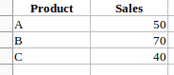

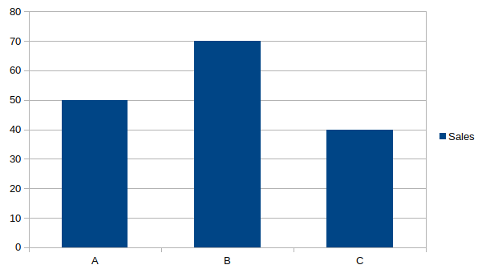
2.Bar Chart:
A bar chart is similar to a column chart but uses horizontal bars. It is useful when category names are long or when comparing values side by side in an easy-to-read way.

Example:
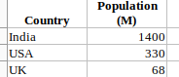

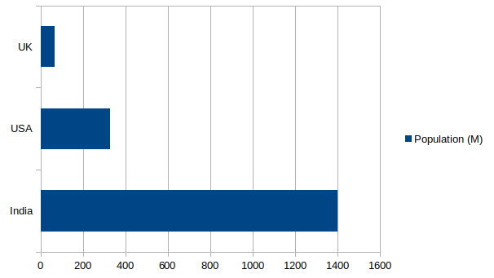

3. Pie Chart:
A pie chart shows parts of a whole in percentages. Each slice of the circle represents the proportion of a category. It is best when you want to show the contribution of each category to the total.

Example:
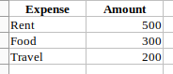
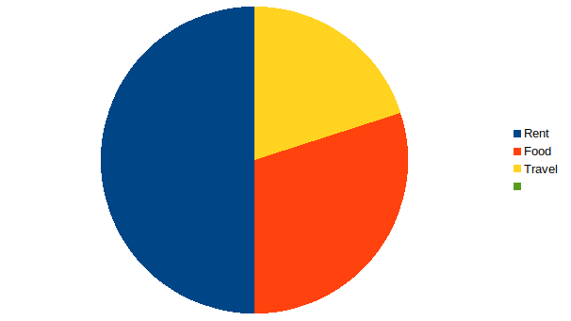

4. Line Chart:
A line chart connects data points with a line, showing trends over time. It is widely used for time-series data like monthly sales, stock prices, or temperature changes.

Example:

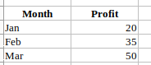
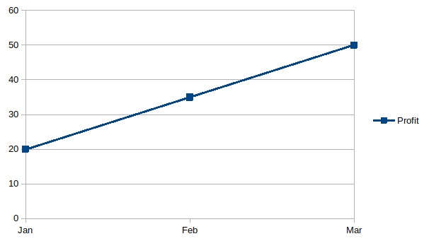

5. Scatter Chart:
A scatter chart plots data points on the X-Y axis to show relationships or correlations between two variables. It is useful in statistical analysis, like studying the effect of hours studied on exam marks.

Example:
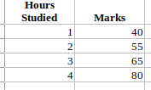

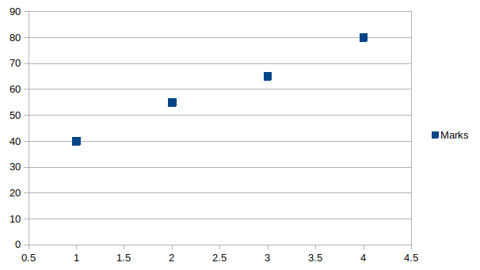

6. Area Chart:
An area chart is like a line chart but with the area below the line filled with color. It emphasizes the magnitude of change over time and helps in showing cumulative values.

Example:

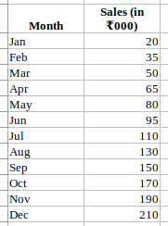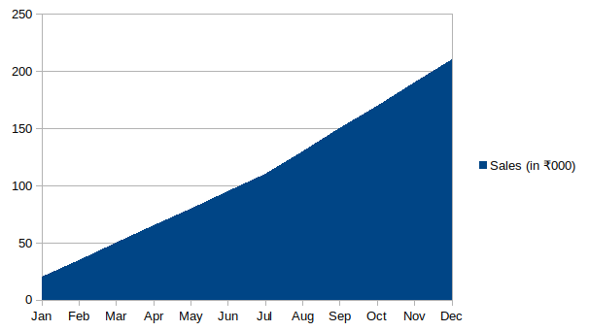

7. Doughnut Chart:
A doughnut chart is similar to a pie chart but with a hole in the center. It allows for better visualization of multiple categories and can also display more than one data series.

Example:

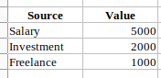

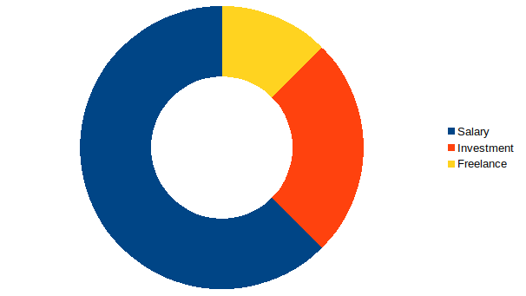

8. Stacked Column Chart
A stacked column chart shows data in vertical bars where each bar is divided into multiple parts (stacked). Each stack represents a category, and the total height represents the overall value. It is useful for comparing totals and also seeing how each category contributes to the total, like monthly expenses divided into rent, food, and travel.

Example:

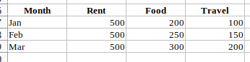

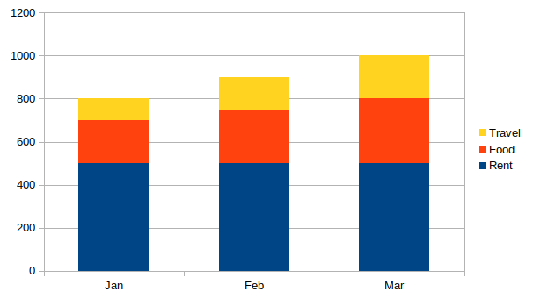

9. Bubble Chart:
A bubble chart is an extension of a scatter chart where each point is represented by a bubble, and the bubble size represents a third variable. It is useful for visualizing three-dimensional data.

Example:
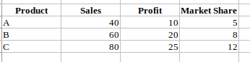
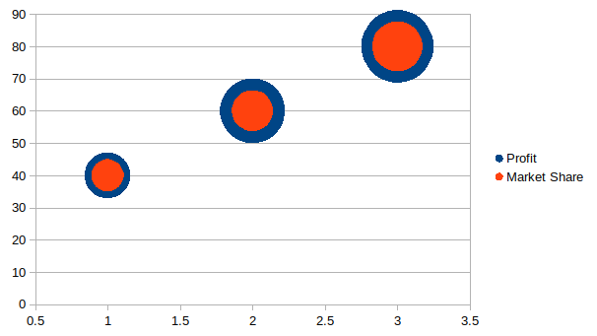
10. Radar Chart (Spider Chart):
A radar chart displays multivariate data in a circular format, with each axis representing a variable. It is helpful for comparing performance across multiple criteria, like employee skills or product features.

Example:
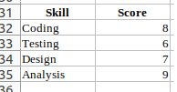
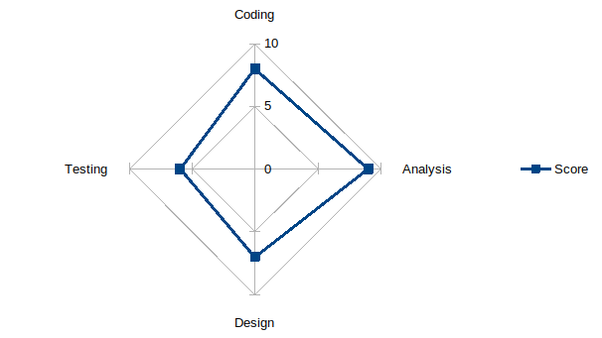
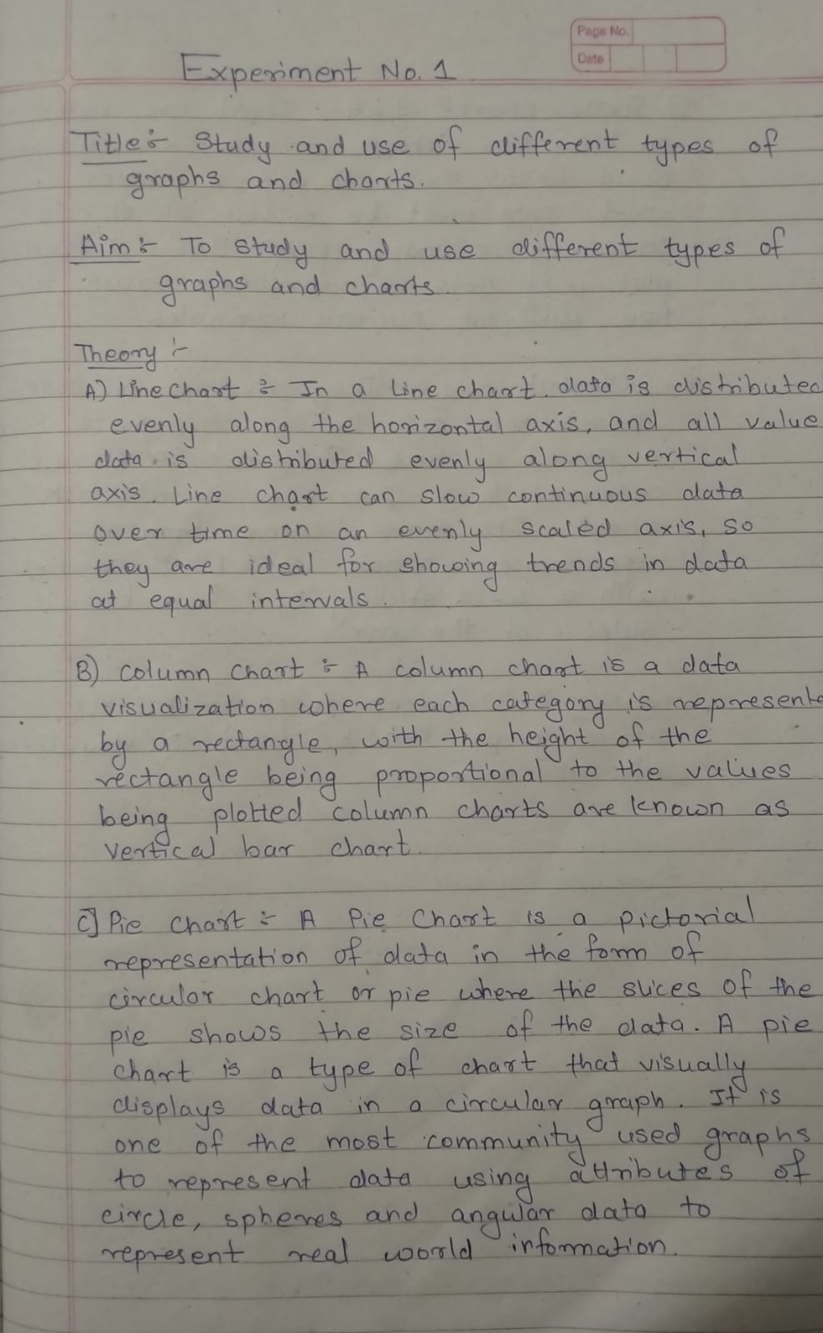
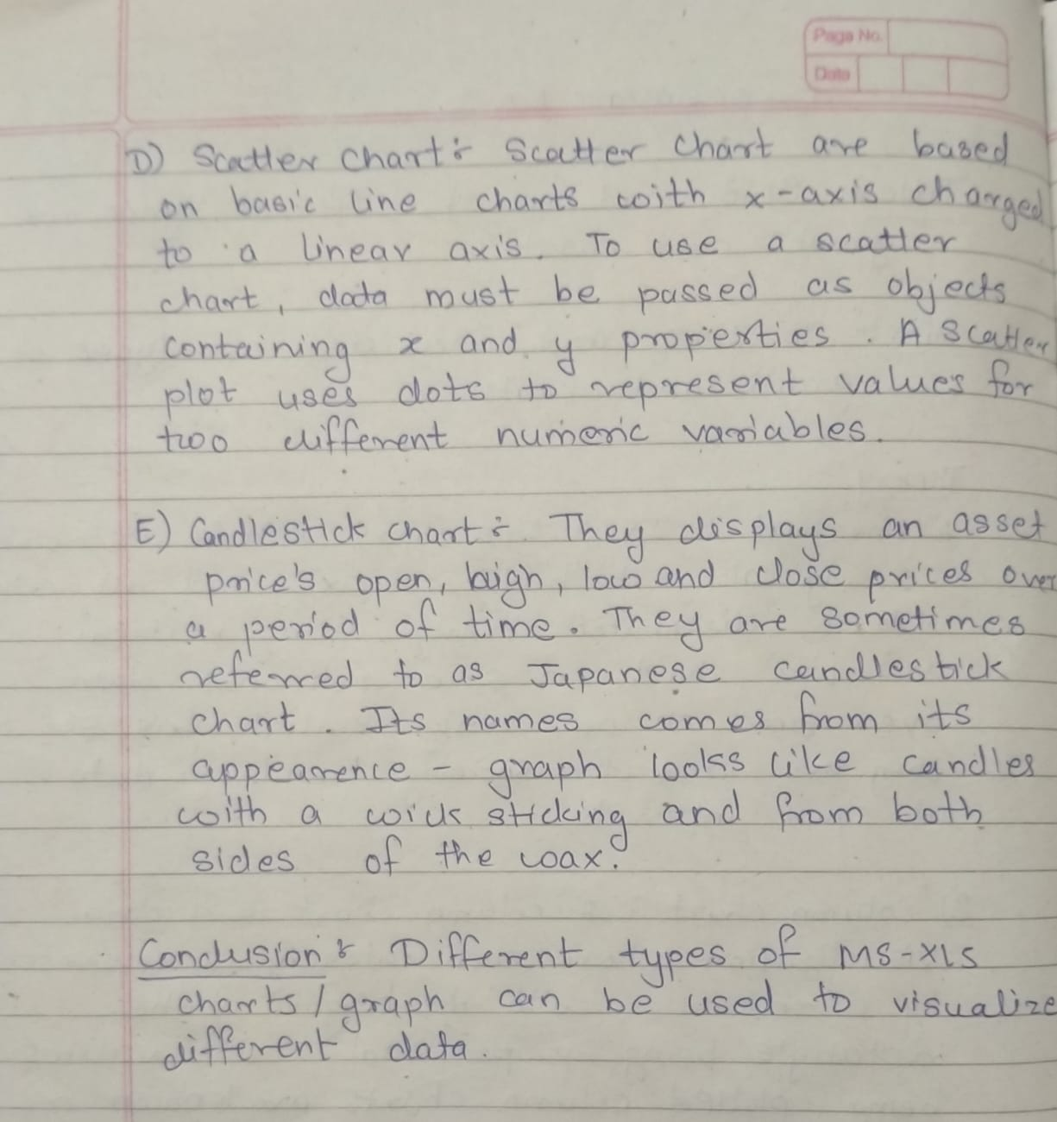

Assignment 2

Title: Normalization Techniques

Aim: To study and use different types of Normalization Techniques

Theory:
1. Min-Max Normalization (Range: 1 to 5)
Min-Max Normalization rescales the feature to a fixed range — in this case, between 1 and 5. It's useful when the data needs to be confined to a specific interval.
Formula:
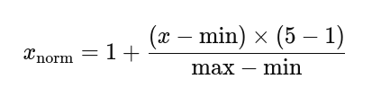
- min = Minimum value in the column
- max = Maximum value in the column
- Resulting values lie within the range [1, 5]
Use When:
- You need normalized values within a specific range
- The dataset does not contain outliers, as they will skew the results

2. Z-Score Normalization (Standardization)
Z-Score normalization (also called standardization) transforms the data so it has a mean of 0 and a standard deviation of 1. It helps compare data with different scales or distributions.
Formula:
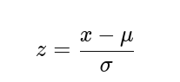
- μ: mean of the values
- σ: standard deviation
- Resulting values can be positive or negative, depending on how far they are from the mean
Use When:
- The data may contain outliers
- The model assumes Gaussian distribution (e.g., SVM, linear regression)
- Feature comparison is needed across different units or scales

3. Decimal Scaling Normalization
Decimal Scaling moves the decimal point of values so the maximum absolute value becomes less than 1. It's a simple method to scale values without changing their distribution shape.
Formula:
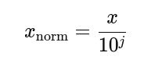
Where J is the smallest integer such that:
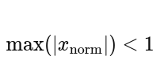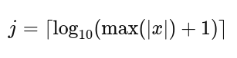
Use When:
- You want a very fast and simple scaling method
- Preserving relative magnitudes is important
Algorithm:

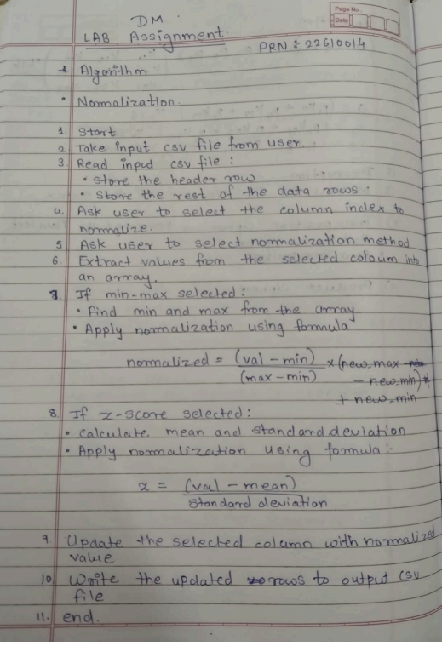

Code:

import java.io.*;
import java.util.*;

public class CSVColumnNormalizer {
public static void main(String[] args) throws IOException {
Scanner scanner = new Scanner(System.in);

System.out.print("Enter input CSV file name (e.g., input.csv): ");
String inputFile = scanner.nextLine();
System.out.print("Enter output CSV file name (e.g., output.csv): ");
String outputFile = scanner.nextLine();

List<String[]> rows = new ArrayList<>();
BufferedReader reader = new BufferedReader(new FileReader(inputFile));
String headerLine = reader.readLine();
String[] headers = headerLine.split(",");
rows.add(headers);

String line;
while ((line = reader.readLine()) != null) {
rows.add(line.split(","));
}
reader.close();

System.out.println("\nAvailable columns:");
for (int i = 0; i < headers.length; i++) {
System.out.println(i + ": " + headers[i]);
}

System.out.print("\nEnter the column index to normalize: ");
int colIndex = scanner.nextInt();

System.out.println("Choose normalization method:");
System.out.println("1. Min-Max Normalization (Range: 1 to 5)");
System.out.println("2. Z-Score Normalization");
System.out.println("3. Decimal Scaling Normalization");
System.out.print("Enter choice (1, 2 or 3): ");
int method = scanner.nextInt();

double[] values = new double[rows.size() - 1];
for (int i = 1; i < rows.size(); i++) {
values[i - 1] = Double.parseDouble(rows.get(i)[colIndex]);
}

if (method == 1) {
// Min-Max Normalization (1 to 5)
double min = Arrays.stream(values).min().getAsDouble();
double max = Arrays.stream(values).max().getAsDouble();
for (int i = 1; i < rows.size(); i++) {
double norm = 1 + (values[i - 1] - min) * 4.0 / (max - min);
rows.get(i)[colIndex] = String.format("%.4f", norm);
}
} else if (method == 2) {
// Z-Score Normalization
double mean = Arrays.stream(values).average().getAsDouble();
double stdDev = Math.sqrt(Arrays.stream(values)
.map(v -> Math.pow(v - mean, 2))
.average()
.orElse(0.0));
for (int i = 1; i < rows.size(); i++) {
double z = (values[i - 1] - mean) / stdDev;
rows.get(i)[colIndex] = String.format("%.4f", z);
}
} else if (method == 3) {
// Decimal Scaling Normalization
double maxAbs = Arrays.stream(values)
.map(Math::abs)
.max()
.orElse(1.0);
int j = (int) Math.ceil(Math.log10(maxAbs + 1));
double divisor = Math.pow(10, j);
for (int i = 1; i < rows.size(); i++) {
double norm = values[i - 1] / divisor;
rows.get(i)[colIndex] = String.format("%.4f", norm);
}
} else {
System.out.println("Invalid choice.");
return;
}

BufferedWriter writer = new BufferedWriter(new FileWriter(outputFile));
for (String[] row : rows) {
writer.write(String.join(",", row));
writer.newLine();
}
writer.close();

System.out.println("Normalization complete. Output saved to: " + outputFile);
}
}

Output:
- Min - Max Normalization
Column Normalized = Sepal Width
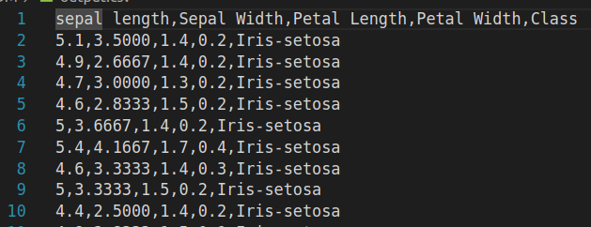
- Z - Score Normalization
Column Normalized = Petal Width
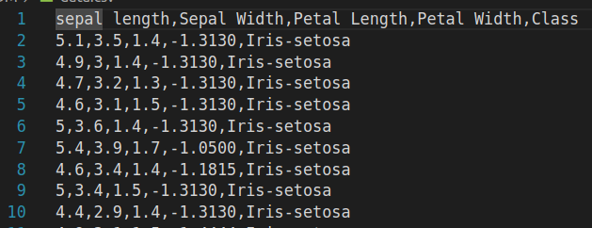
- Decimal Scaling
Column Normalized = Petal Length
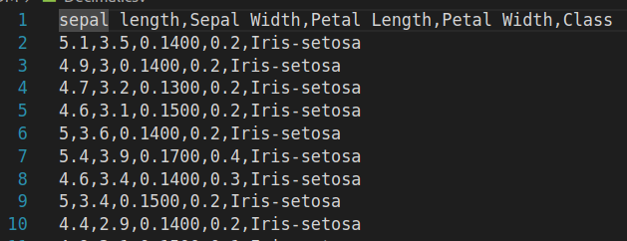
Conclusion
This experiment helped me understand the importance of normalization in data mining. Normalization is used to scale numeric data so that all values fall within a similar range, making it easier for data mining algorithms like clustering and classification to work effectively.There are different techniques for normalization:
- Min-Max Normalization scales the data to a range between 0 and 1.
- Z-Score Normalization transforms the data so it is centered around the mean, with a standard deviation of 1.
- Decimal Scaling reduces large numbers by moving the decimal point.
These methods improve the accuracy and performance of data analysis.

Assignment 2

Title: OLAP Implementation

Theory:

What is OLAP?
OLAP (Online Analytical Processing) is a category of software technology that enables analysts, managers, and executives to gain insight into data through fast, interactive queries and multidimensional analysis. It allows users to analyze data across multiple dimensions (e.g., time, location, product) to uncover trends, patterns, and exceptions.
OLAP Data Model: Multidimensional Cubes
- OLAP organizes data into multidimensional cubes.
- Each dimension represents a perspective or attribute (e.g., Date, Region, Product).
- The facts (measures) in the cube are typically numeric values like sales, profits, or quantities.
- This model allows slicing, dicing, drilling, and rolling up data along different dimensions.
Common OLAP Operations
- Slice
- Definition:
Slicing extracts a subset of the OLAP cube by selecting a single value for one dimension, effectively creating a new sub-cube.
- Example:
If you have a sales cube with dimensions Date, Region, and Product, slicing by Date = "2023-01-01" will give all sales data on that particular day.
- Purpose:
Focus analysis on one specific dimension value to see a cross-section of data.

- Dice
- Definition:
Dicing extracts a sub-cube by specifying a range or set of values for multiple dimensions.
- Example:
From the sales cube, a dice operation might select Date between "2023-01-01" and "2023-01-31" and Region in {“East”, “West”}, giving a smaller cube filtered on multiple criteria.
- Purpose:
Allows multi-dimensional filtering and exploring a focused dataset.
- Roll-Up (Aggregation)
- Definition:
Roll-up aggregates data by climbing up a concept hierarchy or by reducing the dimensions.
- Example:
Summing sales data by Month instead of Date, or by Country instead of Region.
- Purpose:
Provides summarized views and insights at a higher level of abstraction.
- Hierarchies:
Dimensions often have hierarchies, e.g., Date → Month → Quarter → Year.

- Drill-Down
- Definition:
The opposite of roll-up; it breaks data down to more detailed levels.
- Example:
Drilling down from Year → Quarter → Month → Day to view finer granularity of sales.
- Purpose:
Allows detailed inspection and understanding of the summarized data.
- Pivot (Rotate)
- Definition:
Pivoting rotates the cube’s axes to provide a different perspective on the data.
- Example:
Switching the rows and columns in a pivot table (e.g., swapping Product and Region axes) to view sales differently.
- Purpose:
Enhances data visualization and comparative analysis by reorganizing dimensions.
Why Use OLAP Operations?
- To answer complex business questions quickly.
- To explore data interactively and discover hidden insights.
- To summarize, filter, and analyze data from different angles.
- To enable business users to perform self-service analysis without deep technical skills.

Algorithm: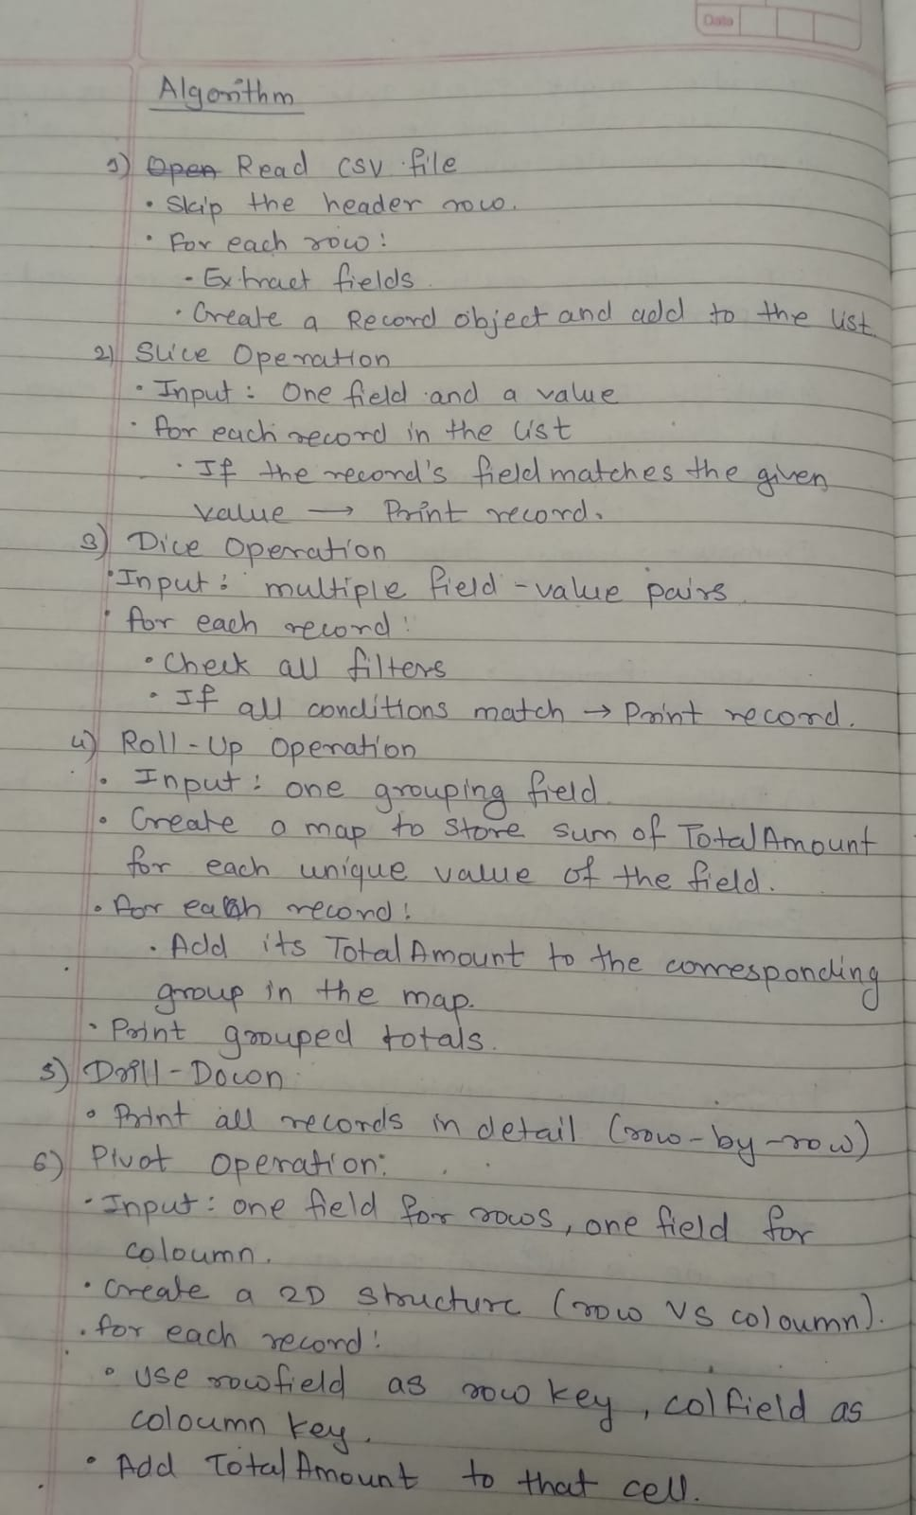

Code:
import java.io.BufferedReader;
import java.io.FileReader;
import java.io.IOException;
import java.util.*;

class Record {
String Date;
String Gender;
String ProductCategory;
int Quantity;
double PricePerUnit;
double TotalAmount;

Record(String Date, String Gender, String ProductCategory, int Quantity, double PricePerUnit, double TotalAmount) {
this.Date = Date;
this.Gender = Gender;
this.ProductCategory = ProductCategory;
this.Quantity = Quantity;
this.PricePerUnit = PricePerUnit;
this.TotalAmount = TotalAmount;
}

void printRecord() {
System.out.println(Date + " | " + Gender + " | " + ProductCategory + " | Quantity: " + Quantity
+ " | PricePerUnit: " + PricePerUnit + " | TotalAmount: " + TotalAmount);
}
}

public class OLAPOperations {

static List<Record> readCSV(String filename) {
List<Record> records = new ArrayList<>();
try (BufferedReader br = new BufferedReader(new FileReader(filename))) {
String line = br.readLine(); // Skip header
while ((line = br.readLine()) != null) {
String[] parts = line.split(",");
if (parts.length == 9) {
// Parse fields relevant to us
String date = parts[1];
String gender = parts[3];
String productCategory = parts[5];
int quantity = Integer.parseInt(parts[6]);
double pricePerUnit = Double.parseDouble(parts[7]);
double totalAmount = Double.parseDouble(parts[8]);

records.add(new Record(date, gender, productCategory, quantity, pricePerUnit, totalAmount));
}
}
} catch (IOException e) {
System.out.println("File not found or error reading file!");
}
return records;
}

static String toLower(String s) {
return s.toLowerCase();
}

static void sliceOperation(List<Record> data, String field, String value) {
System.out.println("\nSlice: " + field + " = " + value);
for (Record r : data) {
if ((field.equalsIgnoreCase("Date") && toLower(r.Date).equals(toLower(value))) ||
(field.equalsIgnoreCase("Gender") && toLower(r.Gender).equals(toLower(value))) ||
(field.equalsIgnoreCase("ProductCategory") && toLower(r.ProductCategory).equals(toLower(value)))) {
r.printRecord();
}
}
}

static void diceOperation(List<Record> data, Map<String, String> filters) {
System.out.println("\nDice:");
for (Record r : data) {
boolean match = true;
for (Map.Entry<String, String> f : filters.entrySet()) {
String field = f.getKey();
String val = toLower(f.getValue());

if ((field.equalsIgnoreCase("Date") && !toLower(r.Date).equals(val)) ||
(field.equalsIgnoreCase("Gender") && !toLower(r.Gender).equals(val)) ||
(field.equalsIgnoreCase("ProductCategory") && !toLower(r.ProductCategory).equals(val))) {
match = false;
break;
}
}
if (match) r.printRecord();
}
}

static void rollupOperation(List<Record> data, String groupField) {
System.out.println("\nRoll up: (Total Amount grouped by " + groupField + ")");
Map<String, Double> totals = new HashMap<>();

for (Record r : data) {
String key = "";
if (groupField.equalsIgnoreCase("Date")) key = r.Date;
else if (groupField.equalsIgnoreCase("Gender")) key = r.Gender;
else if (groupField.equalsIgnoreCase("ProductCategory")) key = r.ProductCategory;
else continue;

totals.put(key, totals.getOrDefault(key, 0.0) + r.TotalAmount);
}

for (Map.Entry<String, Double> entry : totals.entrySet()) {
System.out.println(entry.getKey() + " → " + entry.getValue());
}
}

static void drilldownOperation(List<Record> data) {
System.out.println("\nDrill-down:");
for (Record r : data) {
r.printRecord();
}
}

static void pivotOperation(List<Record> data, String rowField, String colField) {
System.out.println("\nPivot: " + rowField + " vs " + colField);

Map<String, Map<String, Double>> pivot = new HashMap<>();
Set<String> colValues = new TreeSet<>();

for (Record r : data) {
String rowKey = "";
String colKey = "";

if (rowField.equalsIgnoreCase("Date")) rowKey = r.Date;
else if (rowField.equalsIgnoreCase("Gender")) rowKey = r.Gender;
else if (rowField.equalsIgnoreCase("ProductCategory")) rowKey = r.ProductCategory;
else continue;

if (colField.equalsIgnoreCase("Date")) colKey = r.Date;
else if (colField.equalsIgnoreCase("Gender")) colKey = r.Gender;
else if (colField.equalsIgnoreCase("ProductCategory")) colKey = r.ProductCategory;
else continue;

colValues.add(colKey);

pivot.putIfAbsent(rowKey, new HashMap<>());
Map<String, Double> innerMap = pivot.get(rowKey);
innerMap.put(colKey, innerMap.getOrDefault(colKey, 0.0) + r.TotalAmount);
}

// Print header
System.out.print(rowField);
for (String c : colValues) {
System.out.print("\t" + c);
}
System.out.println();

// Print rows
for (String row : pivot.keySet()) {
System.out.print(row);
Map<String, Double> innerMap = pivot.get(row);
for (String c : colValues) {
System.out.print("\t" + innerMap.getOrDefault(c, 0.0));
}
System.out.println();
}
}

public static void main(String[] args) {
Scanner sc = new Scanner(System.in);

System.out.print("Enter CSV file name (with extension): ");
String filename = sc.nextLine();

List<Record> data = readCSV(filename);
if (data.isEmpty()) {
System.out.println("No data loaded");
sc.close();
return;
}

while (true) {
System.out.println("\n* OLAP Menu *");
System.out.println("1. Original Data");
System.out.println("2. Slice");
System.out.println("3. Dice");
System.out.println("4. Roll-Up");
System.out.println("5. Drill-Down");
System.out.println("6. Pivot");
System.out.println("0. Exit");
System.out.print("Enter your choice: ");

String choice = sc.nextLine();

switch (choice) {
case "1":
System.out.println("\nOriginal Data:");
for (Record r : data)
r.printRecord();
break;
case "2":
System.out.print("Enter field to slice by (Date/Gender/ProductCategory): ");
String sliceField = sc.nextLine();
System.out.print("Enter value for " + sliceField + ": ");
String sliceValue = sc.nextLine();
sliceOperation(data, sliceField, sliceValue);
break;
case "3":
System.out.print("How many filters? ");
int numFilters = Integer.parseInt(sc.nextLine());
Map<String, String> filters = new HashMap<>();
for (int i = 0; i < numFilters; i++) {
System.out.print("Enter field name (Date/Gender/ProductCategory): ");
String fField = sc.nextLine();
System.out.print("Enter value for " + fField + ": ");
String fValue = sc.nextLine();
filters.put(fField, fValue);
}
diceOperation(data, filters);
break;
case "4":
System.out.print("Enter field to group by (Date/Gender/ProductCategory): ");
String rollField = sc.nextLine();
rollupOperation(data, rollField);
break;
case "5":
drilldownOperation(data);
break;
case "6":
System.out.print("Enter row field (Date/Gender/ProductCategory): ");
String rowField = sc.nextLine();
System.out.print("Enter column field (Date/Gender/ProductCategory): ");
String colField = sc.nextLine();
pivotOperation(data, rowField, colField);
break;
case "0":
System.out.println("Exiting...");
sc.close();
return;
default:
System.out.println("Invalid choice");
}
}
}
}

Output:
Original data :
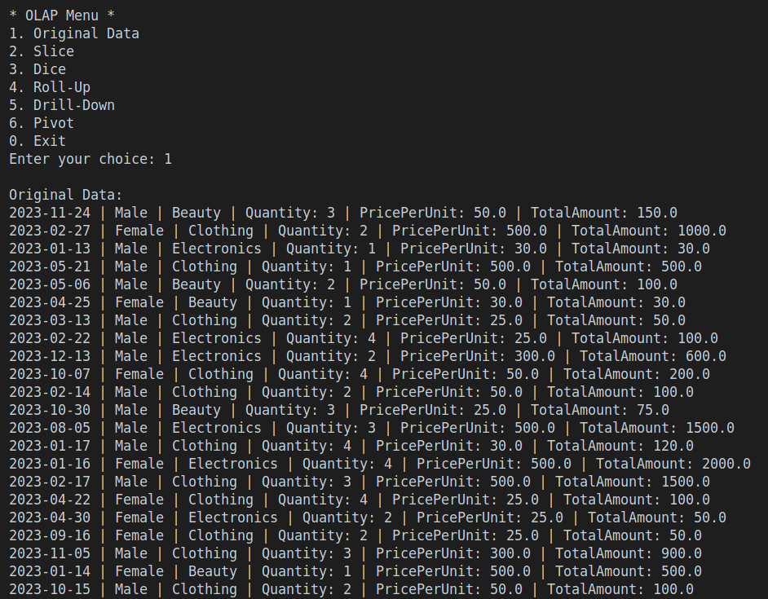

- Slice :
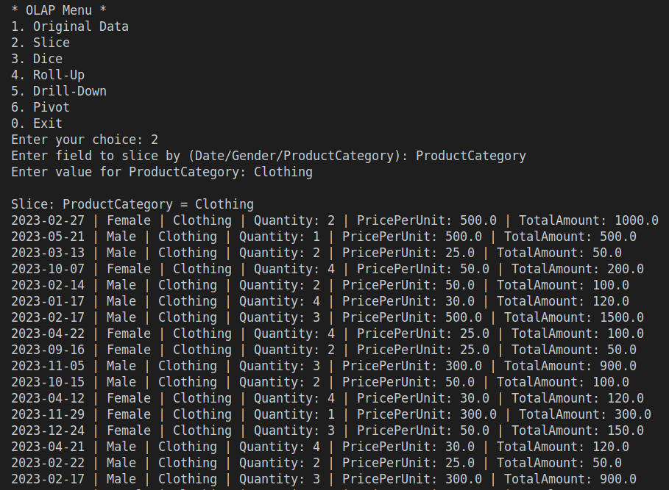
- Dice :
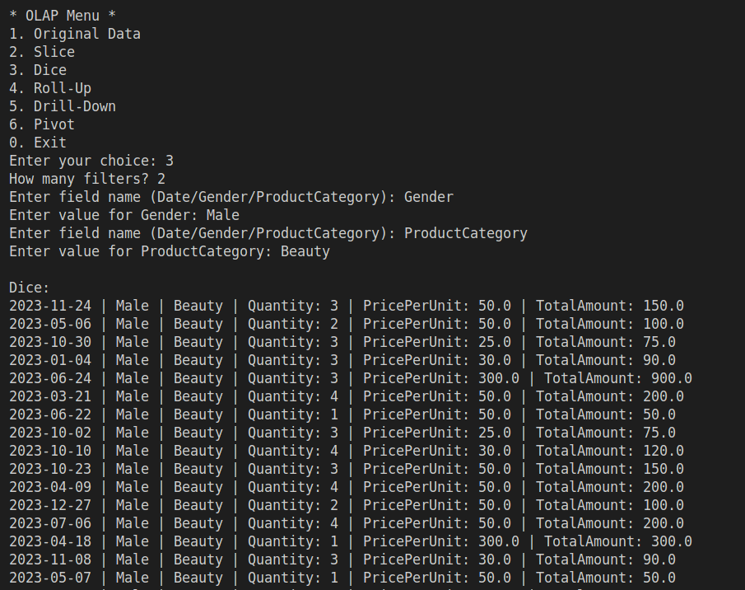
- Roll-Up
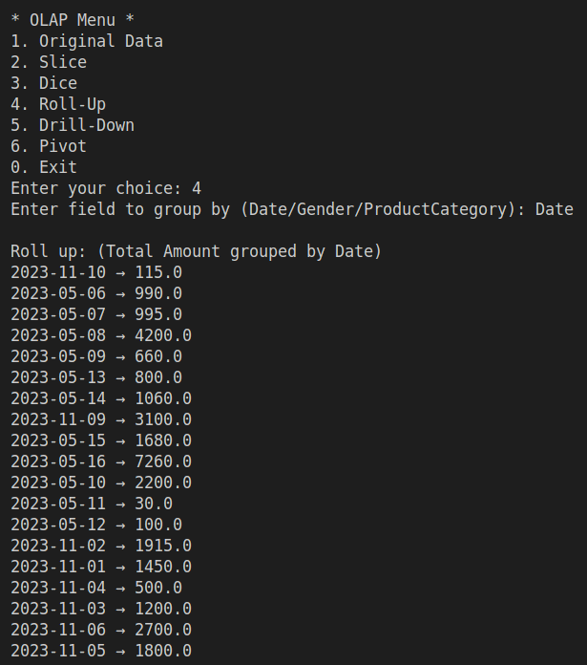
- Drill - Down :
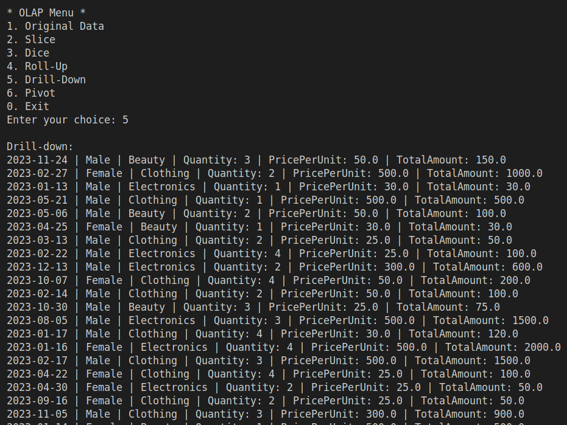
- Pivot:
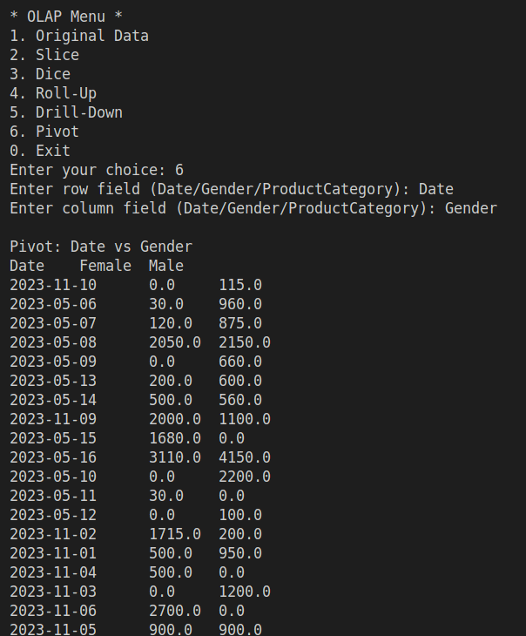
Conclusion:
In this experiment, I successfully explored and implemented key OLAP operations—Slice, Dice, Roll-Up, Drill-Down, and Pivot—on a multidimensional dataset stored in a CSV file. By coding these operations, I gained practical insight into how OLAP techniques facilitate efficient data analysis by enabling users to interactively explore data across multiple dimensions. These operations proved essential for summarizing large datasets, filtering information based on specific criteria, and rearranging data views to uncover meaningful patterns and trends. Overall, this exercise reinforced the importance of OLAP in supporting complex decision-making processes through flexible and fast multidimensional data analysis.

Assignment 3

Title: Study on class comparison using D weight and T weight

Aim: To calculate D weight and T weight for given data

Theory:
t-weight and d-weight are percentage measures used to analyze data in tabular form. t-weight shows the share of a value with respect to its row total, while d-weight shows the share of a value with respect to its column total. They are used because raw numbers alone may not reveal patterns clearly, but percentages make it easier to compare contributions across rows and columns, helping in better interpretation of data distribution.

Algorithm:

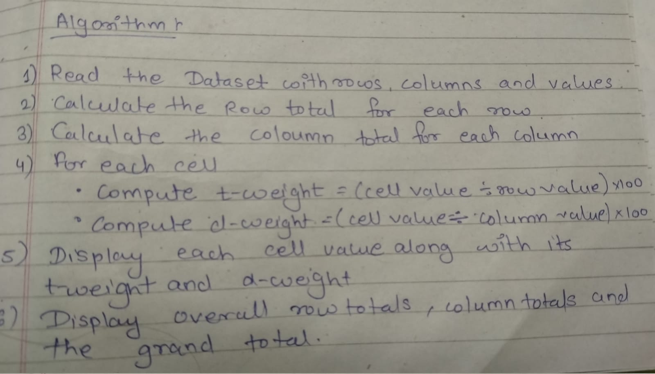

Input Data:
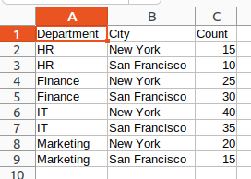

Code:

import java.io.*;
import java.util.*;

public class Exp3 {

public static void main(String[] args) {
String inputFile = "exp3_input.csv";
String outputFile = "exp3_output.csv";

Map<String, Map<String, Integer>> classRowColMap = new HashMap<>();
Map<String, Integer> colMap = new HashMap<>();
Map<String, Integer> rowMap = new HashMap<>();

try (BufferedReader br = new BufferedReader(new FileReader(inputFile))) {
String line;
int i = 0;

while ((line = br.readLine()) != null) {

if (i == 0) {
i++;
continue;
}

String[] parts = line.split(",");
if (parts.length < 3) continue;

String row = parts[0].trim();
String col = parts[1].trim();
int val = Integer.parseInt(parts[2].trim());

classRowColMap.putIfAbsent(row, new HashMap<>());
classRowColMap.get(row).put(col, val);

colMap.put(col, colMap.getOrDefault(col, 0) + val);
rowMap.put(row, rowMap.getOrDefault(row, 0) + val);
}
} catch (Exception e) {
System.out.println("Couldn't open file: " + e.getMessage());
return;
}

int colsum = colMap.values().stream().mapToInt(Integer::intValue).sum();

List<String> columns = new ArrayList<>(colMap.keySet());
Collections.sort(columns);

// Write output CSV with proper headers
try (PrintWriter pw = new PrintWriter(new FileWriter(outputFile))) {
// Header
pw.print("Department,");
for (String col : columns) {
pw.printf("%s Count,%s t-weight,%s d-weight,", col, col, col);
}
pw.println("Total Count,t-weight,d-weight");

// Rows
for (String row : rowMap.keySet()) {
pw.print(row + ",");
for (String col : columns) {
int countVal = classRowColMap.getOrDefault(row, new HashMap<>()).getOrDefault(col, 0);

pw.print(countVal + ",");
pw.printf("%.2f%%,", ((float) countVal / rowMap.get(row)) * 100);
pw.printf("%.2f%%,", ((float) countVal / colMap.get(col)) * 100);
}
pw.printf("%d,100.00%%,%.2f%%\n", rowMap.get(row), ((float) rowMap.get(row) / colsum) * 100);
}

// Totals row
pw.print("Total,");
for (String col : columns) {
int val = colMap.get(col);
pw.print(val + ",");
pw.printf("%.2f%%,", ((float) val / colsum) * 100);
pw.print("100.00%,");
}
pw.println(colsum + ",100.00%,100.00%");
} catch (IOException e) {
System.out.println("Error writing file: " + e.getMessage());
}

System.out.println("exp3_output.csv generated successfully!");
}
}

Output:

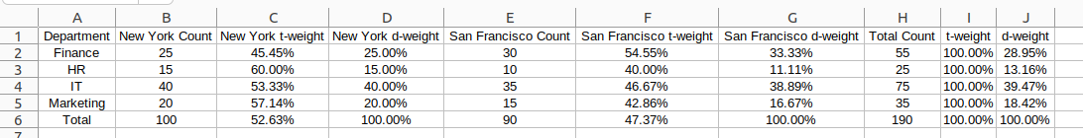

Conclusion:
t-weight and d-weight make it easier to understand data by showing percentages instead of just numbers. From the output, we can observe that t-weight tells us how much each value contributes within its row, while d-weight shows how much it contributes within its column. This makes patterns clearer, helps in easy comparison, and gives better insights than looking at raw numbers alone.

Assignment 4

Title: Five number summary and box plot

Aim: To find a 5 number summary of a dataset.

Theory:
A boxplot (also called a box-and-whisker plot) is a way of showing how a set of numbers is spread out. It is based on five important values, called the five-number summary:
- Minimum – the smallest value in the data.
- First Quartile (Q1) – the value that separates the lowest 25% of the data.
- Median (Q2) – the middle value of the data (half of the numbers are smaller, half are larger).
- Third Quartile (Q3) – the value that separates the lowest 75% of the data (or the top 25%).
- Maximum – the largest value in the data.
The Interquartile Range (IQR) is the difference between Q3 and Q1 (IQR = Q3 – Q1). It tells us how spread out the middle 50% of the data is.
A boxplot uses these values to create a simple graph:
- The box shows the range from Q1 to Q3.
- A line inside the box shows the median (Q2).
- The whiskers extend from the box to the minimum and maximum values that are within a certain range.
- Any values that are too far from the rest are shown as outliers.
Input Dataset: data.csv
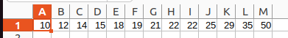

Algorithm:
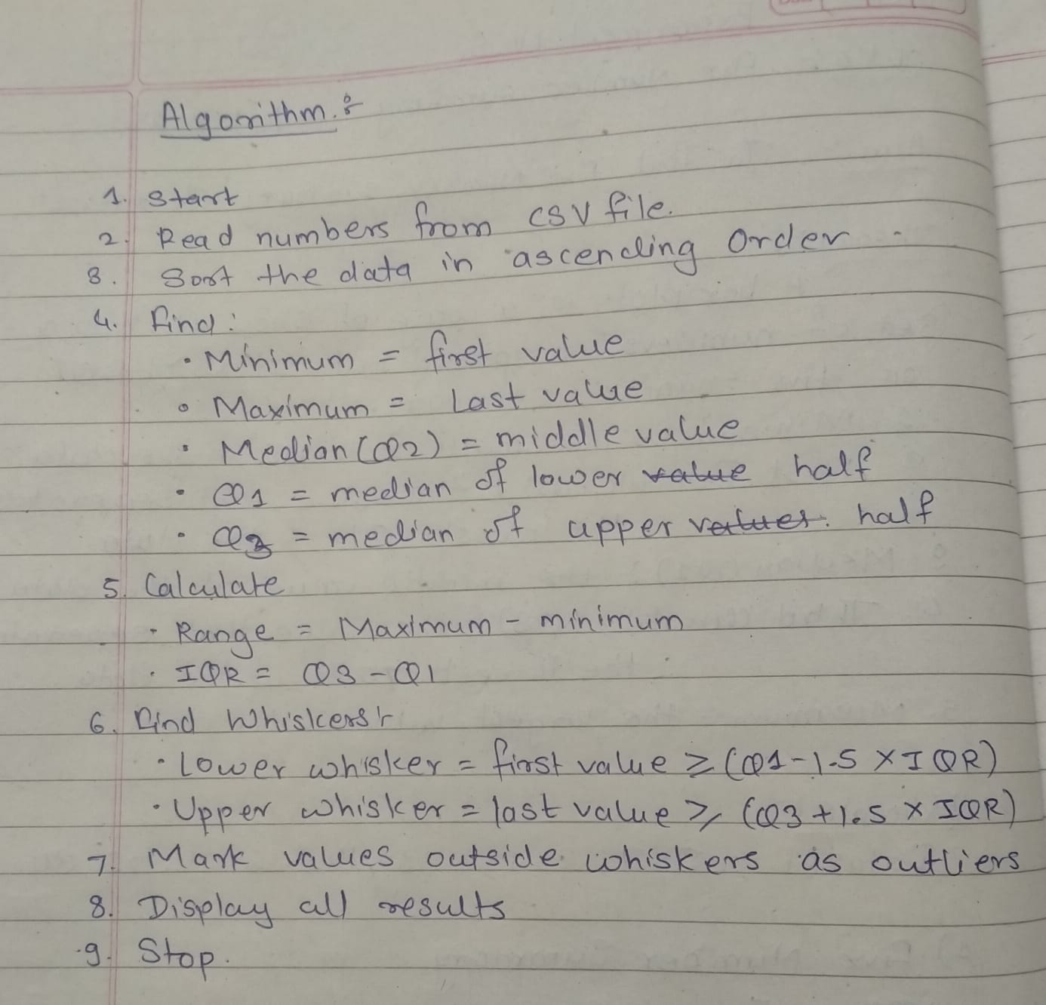
Code:
import java.io.*;
import java.util.*;

public class BoxPlotStats {

public static double median(List<Double> data) {
Collections.sort(data);
int n = data.size();
if (n % 2 == 0)
return (data.get(n / 2 - 1) + data.get(n / 2)) / 2.0;
else
return data.get(n / 2);
}

public static void main(String[] args) {
List<Double> data = new ArrayList<>();

try (BufferedReader br = new BufferedReader(new FileReader("data.csv"))) {
String line = br.readLine(); // read first line only
if (line != null) {
String[] values = line.split(",");
for (String val : values) {
data.add(Double.parseDouble(val.trim()));
}
}
} catch (IOException e) {
System.out.println("Unable to open file!");
return;
}

if (data.isEmpty()) {
System.out.println("No data found in the file.");
return;
}

Collections.sort(data);
System.out.println("Sorted data: " + data + "\n");

double minVal = data.get(0);
double maxVal = data.get(data.size() - 1);
double Q2 = median(data);

List<Double> lowerHalf = new ArrayList<>(data.subList(0, data.size() / 2));
List<Double> upperHalf;
if (data.size() % 2 == 0)
upperHalf = new ArrayList<>(data.subList(data.size() / 2, data.size()));
else
upperHalf = new ArrayList<>(data.subList(data.size() / 2 + 1, data.size()));

double Q1 = median(lowerHalf);
double Q3 = median(upperHalf);

double IQR = Q3 - Q1;
double range = maxVal - minVal;

System.out.println("Minimum Value: " + minVal);
System.out.println("First Quartile (Q1): " + Q1);
System.out.println("Median (Q2): " + Q2);
System.out.println("Third Quartile (Q3): " + Q3);
System.out.println("Maximum Value: " + maxVal);
System.out.println("Range: " + range);
System.out.println("Interquartile Range (IQR): " + IQR);

double lowerBound = Q1 - 1.5 * IQR;
double upperBound = Q3 + 1.5 * IQR;

System.out.println("\nLower Bound for whisker: " + lowerBound);
System.out.println("Upper Bound for whisker: " + upperBound);

double lowerWhisker = minVal;
for (double val : data) {
if (val >= lowerBound) {
lowerWhisker = val;
break;
}
}

double upperWhisker = maxVal;
for (int i = data.size() - 1; i >= 0; i--) {
if (data.get(i) <= upperBound) {
upperWhisker = data.get(i);
break;
}
}

System.out.println("Lower Whisker: " + lowerWhisker);
System.out.println("Upper Whisker: " + upperWhisker);

List<Double> outliers = new ArrayList<>();
for (double val : data) {
if (val < lowerWhisker || val > upperWhisker)
outliers.add(val);
}

System.out.print("\nOutliers: ");
if (outliers.isEmpty())
System.out.println("None");
else
System.out.println(outliers);
}
}

Output:
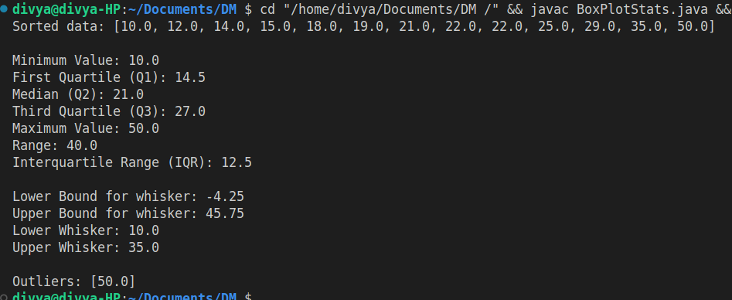
Conclusion:
From the output, we can see how the data is spread out. The program shows the smallest value, biggest value, middle value, and quartiles. The range and IQR tell us how wide the data is, and the whiskers with outliers help us spot unusual values.

Assignment 5

Title: Implementation of Apriori Algorithm

Aim: To calculate frequent itemsets and generate association rules for the given transactional data using the Apriori algorithm.

Theory:
The Apriori Algorithm is a classic data mining technique used for frequent itemset generation and association rule mining in transactional databases. It is widely used in market basket analysis to discover interesting relationships between items purchased together.
- Frequent Itemset:
An itemset is considered frequent if its occurrence in the dataset is greater than or equal to a minimum support threshold. For example, if at least 30% of transactions contain {milk, bread}, then {milk, bread} is a frequent itemset.
- Support:
Support of an itemset is the fraction of transactions in which the itemset appears.
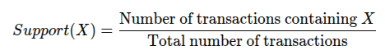
- Confidence:
Confidence is a measure of the reliability of an association rule. For a rule X→Y:
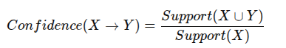
- Apriori Principle:
If an itemset is frequent, then all of its subsets must also be frequent. Conversely, if an itemset is infrequent, all supersets of it will also be infrequent. This property helps to reduce the search space significantly.
Applications:
- Market Basket Analysis: Finding products frequently bought together.
- Cross-Selling & Recommendation Systems: Suggesting items to customers based on purchase patterns.
- Web Usage Mining: Discovering frequently visited pages or patterns in web logs.
- Bioinformatics: Identifying frequently occurring patterns in genetic data.
Advantages:
- Simple and easy to implement.
- Reduces search space using the Apriori property.
- Provides actionable insights for business and decision-making.
Limitations:
- Computationally expensive for large datasets due to multiple database scans.
- May generate a large number of candidate itemsets, requiring high memory.

Input Dataset: Transaction.txt
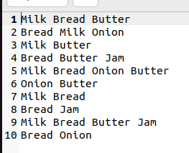
Algorithm:

Program:

import java.io.*;
import java.util.*;

public class Apriori {

static int minSupportCount = 2;

public static void main(String[] args) {
List<Set<String>> transactions = readTransactions("transaction.txt");

if (transactions.isEmpty()) {
System.out.println("No transactions found. Please check the dataset file.");
return;
}

System.out.println("Transactions:");
for (Set<String> t : transactions) {
System.out.println(t);
}

apriori(transactions, minSupportCount);
}

public static List<Set<String>> readTransactions(String fileName) {
List<Set<String>> transactions = new ArrayList<>();
try (BufferedReader br = new BufferedReader(new FileReader(fileName))) {
String line;
while ((line = br.readLine()) != null) {
String[] items = line.trim().split("\\s+|,");
transactions.add(new HashSet<>(Arrays.asList(items)));
}
} catch (IOException e) {
System.out.println("Error reading file: " + e.getMessage());
}
return transactions;
}

public static void apriori(List<Set<String>> transactions, int minSupport) {
Map<Set<String>, Integer> freqItemsets = getFrequentItemsets(transactions, null, minSupport);
int k = 2;

while (!freqItemsets.isEmpty()) {
System.out.println("\nFrequent Itemsets of size " + (k - 1) + ":");
for (Set<String> itemset : freqItemsets.keySet()) {
System.out.println(itemset + " -> Support Count: " + freqItemsets.get(itemset));
}

Set<Set<String>> candidates = generateCandidates(freqItemsets.keySet(), k);
freqItemsets = getFrequentItemsets(transactions, candidates, minSupport);
k++;
}
}

public static Map<Set<String>, Integer> getFrequentItemsets(List<Set<String>> transactions,
Set<Set<String>> candidates,
int minSupport) {
Map<Set<String>, Integer> itemsetCounts = new HashMap<>();

if (candidates == null) {
candidates = new HashSet<>();
for (Set<String> transaction : transactions) {
for (String item : transaction) {
candidates.add(new HashSet<>(Collections.singletonList(item)));
}
}
}

for (Set<String> candidate : candidates) {
for (Set<String> transaction : transactions) {
if (transaction.containsAll(candidate)) {
itemsetCounts.put(candidate, itemsetCounts.getOrDefault(candidate, 0) + 1);
}
}
}

Map<Set<String>, Integer> frequent = new HashMap<>();
for (Set<String> itemset : itemsetCounts.keySet()) {
if (itemsetCounts.get(itemset) >= minSupport) {
frequent.put(itemset, itemsetCounts.get(itemset));
}
}
return frequent;
}

public static Set<Set<String>> generateCandidates(Set<Set<String>> prevFreqItemsets, int k) {
Set<Set<String>> candidates = new HashSet<>();
List<Set<String>> itemsetsList = new ArrayList<>(prevFreqItemsets);

for (int i = 0; i < itemsetsList.size(); i++) {
for (int j = i + 1; j < itemsetsList.size(); j++) {
Set<String> candidate = new HashSet<>(itemsetsList.get(i));
candidate.addAll(itemsetsList.get(j));
if (candidate.size() == k) {
candidates.add(candidate);
}
}
}
return candidates;
}
}

Output:
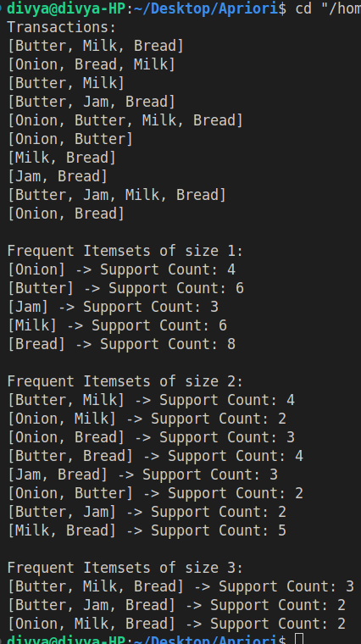

Knime Output:

Weka Output:

Conclusion:
The Apriori Algorithm was successfully implemented to find frequent itemsets and generate association rules from the dataset. The results of our program closely match those obtained from KNIME and WEKA, showing that the implementation is correct. While KNIME and WEKA provide faster processing and visualizations, the program demonstrates the algorithm’s working and can be customized for further analysis. Overall, Apriori effectively discovers meaningful patterns in transactional data.

Assignment 6

Title: Implementation of Clustering Algorithms for Data Analysis

Aim: To group similar data points into clusters using clustering algorithms such as K-Means, Hierarchical Clustering, and DBSCAN

Theory:
Clustering is an unsupervised machine learning technique used to group a set of data points into clusters such that points in the same cluster are more similar to each other than to points in other clusters. Clustering is widely used in data analysis, pattern recognition, image processing, and market segmentation.
Types of Clustering Algorithms:
a) Partitioning Methods (e.g., K-Means):
  - Divides data into K clusters.
  - Iteratively assigns points to the nearest centroid and updates centroids.
  - Advantages: Simple and efficient for large datasets.
  - Limitations: Requires specifying K in advance; sensitive to outliers.
b) Hierarchical Methods (Agglomerative/Divisive):
  - Builds a tree-like structure (dendrogram) representing nested clusters.
  - Agglomerative: Starts with individual points and merges clusters.
  - Divisive: Starts with all data in one cluster and splits iteratively.
  - Advantages: No need to specify number of clusters initially.
  - Limitations: Computationally expensive for large datasets.
c) Density-Based Methods (e.g., DBSCAN):
  - Forms clusters based on dense regions of points.
  - Identifies noise points that do not belong to any cluster.
  - Advantages: Can find clusters of arbitrary shape; robust to noise.
  - Limitations: Sensitive to parameters (eps and minPts).
Applications of Clustering:
- Market Segmentation: Identifying groups of customers with similar behavior.
- Image Segmentation: Grouping pixels with similar properties.
- Anomaly Detection: Detecting outliers in datasets.
- Document/Content Grouping: Clustering similar articles or documents.

Input Dataset:
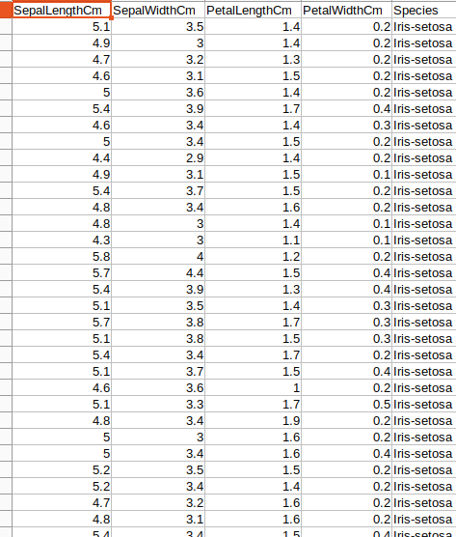

KMean Clustering:
Algorithm:

Program:
import java.io.*;
import java.util.*;

class Point {
double[] features;
int cluster;

Point(double[] features) {
this.features = features;
this.cluster = -1;
}

double distance(Point other) {
double sum = 0;
for (int i = 0; i < features.length; i++) {
sum += Math.pow(this.features[i] - other.features[i], 2);
}
return Math.sqrt(sum);
}

@Override
public String toString() {
return Arrays.toString(features);
}
}

public class KMeansIris {

public static void main(String[] args) {
List<Point> points = readIrisDataset("Iris.csv");

if (points.isEmpty()) {
System.out.println("Dataset not found or empty!");
return;
}

int k = 3; // number of clusters
kmeans(points, k);
}

public static List<Point> readIrisDataset(String fileName) {
List<Point> data = new ArrayList<>();
try (BufferedReader br = new BufferedReader(new FileReader(fileName))) {
String line;
boolean firstLine = true;
while ((line = br.readLine()) != null) {
if (firstLine) { // skip header
firstLine = false;
continue;
}

if (line.trim().isEmpty()) continue;
String[] parts = line.split(",");

// Take only the first 4 numeric columns
int usableColumns = Math.min(4, parts.length);
double[] features = new double[usableColumns];
try {
for (int i = 0; i < usableColumns; i++) {
features[i] = Double.parseDouble(parts[i]);
}
data.add(new Point(features));
} catch (NumberFormatException e) {
continue; // skip invalid rows
}
}
} catch (IOException e) {
System.out.println("Error reading file: " + e.getMessage());
}
return data;
}

public static void kmeans(List<Point> points, int k) {
Random rand = new Random();
List<Point> centroids = new ArrayList<>();

// Step 1: Initialize random centroids
for (int i = 0; i < k; i++) {
centroids.add(points.get(rand.nextInt(points.size())));
}

boolean converged = false;
int iteration = 0;

while (!converged) {
iteration++;
System.out.println("\n--- Iteration " + iteration + " ---");

// Step 2: Assign points to nearest centroid
for (Point p : points) {
double minDist = Double.MAX_VALUE;
int clusterIndex = -1;
for (int i = 0; i < k; i++) {
double dist = p.distance(centroids.get(i));
if (dist < minDist) {
minDist = dist;
clusterIndex = i;
}
}
p.cluster = clusterIndex;
}

// Step 3: Compute new centroids
List<Point> newCentroids = new ArrayList<>();
for (int i = 0; i < k; i++) {
double[] mean = new double[4];
int count = 0;
for (Point p : points) {
if (p.cluster == i) {
for (int j = 0; j < 4; j++) {
mean[j] += p.features[j];
}
count++;
}
}
if (count > 0) {
for (int j = 0; j < 4; j++) {
mean[j] /= count;
}
newCentroids.add(new Point(mean));
} else {
newCentroids.add(centroids.get(i)); // Keep old centroid if empty
}
}

// Step 4: Check for convergence
converged = true;
for (int i = 0; i < k; i++) {
if (centroids.get(i).distance(newCentroids.get(i)) > 1e-6) {
converged = false;
break;
}
}

centroids = newCentroids;
}

// Step 5: Display final results
System.out.println("\n--- Final Results ---");

int totalPoints = points.size();
int[] clusterCounts = new int[k];

for (Point p : points) {
clusterCounts[p.cluster]++;
}

for (int i = 0; i < k; i++) {
double percentage = (clusterCounts[i] * 100.0) / totalPoints;
System.out.printf("Cluster %d: %d points (%.2f%%)\n", i + 1, clusterCounts[i], percentage);
}

System.out.println("\nFinal Centroids:");
for (int i = 0; i < k; i++) {
System.out.println("Centroid " + (i + 1) + ": " + centroids.get(i));
}
for (int i = 0; i < k; i++) {
System.out.println("\nCluster " + (i + 1) + " points:");
for (Point p : points) {
if (p.cluster == i)
System.out.println(p);
}
}
}
}

Program Output:
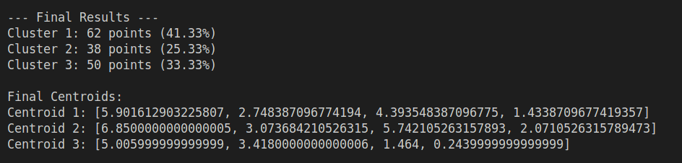

Knime Output:
Weka Output:

Hierarchical Methods (Agglomerative):
Algorithm:

Program:
import java.io.*;
import java.util.*;

class Point {
double[] features;
String label;

Point(double[] f, String label) {
this.features = f;
this.label = label;
}

double distance(Point other) {
double sum = 0;
for (int i = 0; i < features.length; i++)
sum += Math.pow(features[i] - other.features[i], 2);
return Math.sqrt(sum);
}
}

class Cluster {
List<Point> points;

Cluster(List<Point> points) {
this.points = new ArrayList<>(points);
}

double distance(Cluster other, String method) {
double min = Double.MAX_VALUE, max = 0, sum = 0;
int count = 0;
for (Point p1 : this.points) {
for (Point p2 : other.points) {
double d = p1.distance(p2);
min = Math.min(min, d);
max = Math.max(max, d);
sum += d;
count++;
}
}

switch (method.toLowerCase()) {
case "single": return min;
case "complete": return max;
case "average": return sum / count;
default: return sum / count;
}
}
}

public class HierarchicalClusteringIris {

public static void main(String[] args) {
List<Point> points = readIrisDataset("Iris.csv");
if (points.isEmpty()) {
System.out.println("Dataset not found or empty!");
return;
}

String[] linkages = {"single", "average", "complete"};
int k = 3; // number of clusters to cut tree

for (String linkage : linkages) {
System.out.println("\n==============================");
System.out.println(linkage.toUpperCase() + " LINKAGE");
System.out.println("==============================");
printClusterPercentage(points, linkage, k);
}
}

public static List<Point> readIrisDataset(String fileName) {
List<Point> data = new ArrayList<>();
try (BufferedReader br = new BufferedReader(new FileReader(fileName))) {
String line;
boolean first = true;
while ((line = br.readLine()) != null) {
if (first) { first = false; continue; } // skip header
if (line.trim().isEmpty()) continue;
String[] parts = line.split(",");
if (parts.length < 5) continue;
double[] f = new double[4];
for (int i = 0; i < 4; i++) f[i] = Double.parseDouble(parts[i]);
data.add(new Point(f, parts[4]));
}
} catch (Exception e) {
e.printStackTrace();
}
return data;
}

public static void printClusterPercentage(List<Point> points, String linkage, int k) {
// Initialize each point as a cluster
List<Cluster> clusters = new ArrayList<>();
for (Point p : points) clusters.add(new Cluster(Collections.singletonList(p)));

List<Cluster> mergeHistory = new ArrayList<>(clusters);

// Hierarchical clustering until one cluster remains
while (clusters.size() > 1) {
double minDist = Double.MAX_VALUE;
int a = -1, b = -1;
for (int i = 0; i < clusters.size(); i++) {
for (int j = i + 1; j < clusters.size(); j++) {
double d = clusters.get(i).distance(clusters.get(j), linkage);
if (d < minDist) { minDist = d; a = i; b = j; }
}
}

Cluster c1 = clusters.get(a);
Cluster c2 = clusters.get(b);
Cluster merged = new Cluster(new ArrayList<>());
merged.points.addAll(c1.points);
merged.points.addAll(c2.points);

clusters.remove(c2);
clusters.remove(c1);
clusters.add(merged);
mergeHistory.add(merged);
}

// Cut last k clusters from merge history
List<Cluster> finalClusters = mergeHistory.subList(mergeHistory.size() - k, mergeHistory.size());

// Print percentage distribution
System.out.println("Percentage Distribution for k=" + k + " clusters:");
for (int i = 0; i < finalClusters.size(); i++) {
Cluster c = finalClusters.get(i);
double percent = (c.points.size() * 100.0) / points.size();
System.out.printf("Cluster %d: %d points (%.2f%%)\n", i + 1, c.points.size(), percent);
}
}
}
Program Output:
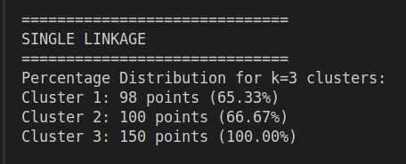
Dendrogram :
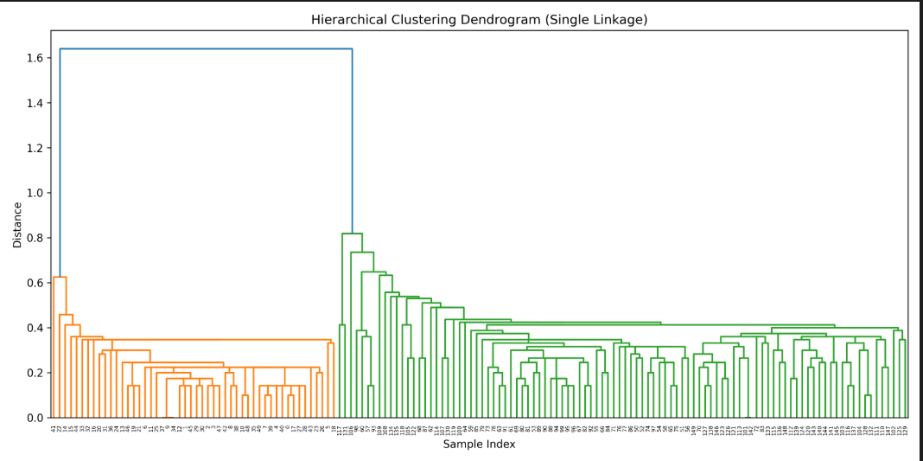
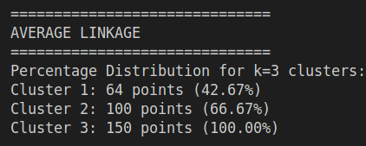
Dendrogram:
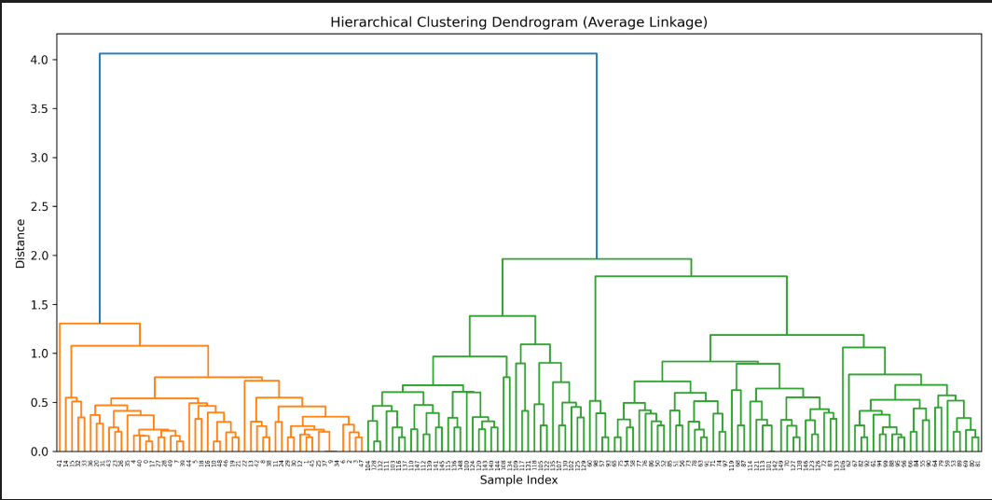

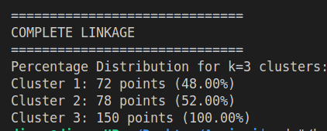
Dendrogram:
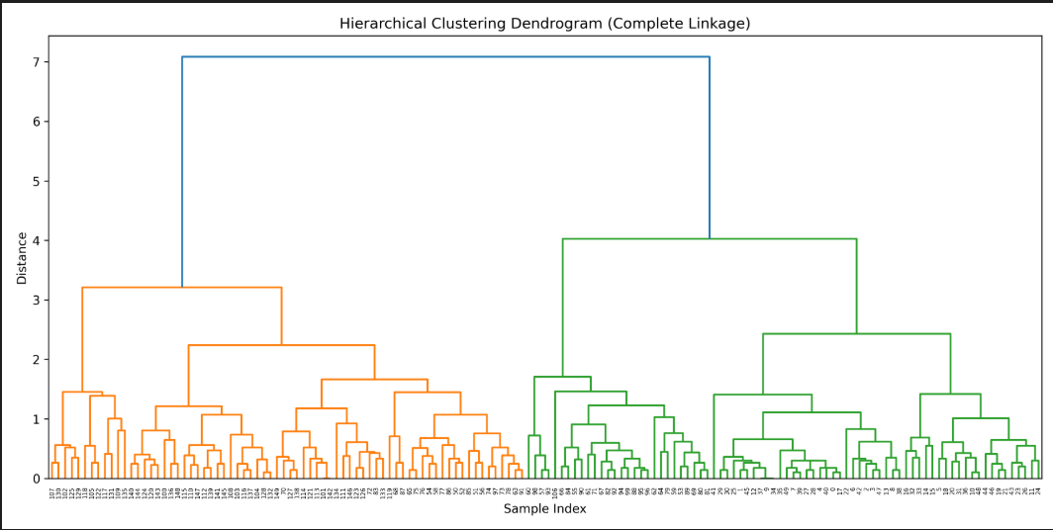
Knime Output:
Weka Output:

Density-Based Methods (DBSCAN):
Algorithm:
Program:
// Source code is decompiled from a .class file using FernFlower decompiler (from Intellij IDEA).
import java.io.BufferedReader;
import java.io.FileReader;
import java.util.ArrayList;
import java.util.HashMap;
import java.util.Iterator;
import java.util.LinkedList;
import java.util.List;
import java.util.Map;

public class DBSCAN {
public DBSCAN() {
}

public static void main(String[] var0) {
List var1 = readIrisDataset("Iris.csv");
if (var1.isEmpty()) {
System.out.println("Dataset not found or empty!");
} else {
double var2 = 0.5;
byte var4 = 5;
dbscan(var1, var2, var4);
HashMap var5 = new HashMap();
Iterator var6 = var1.iterator();

while(var6.hasNext()) {
Point var7 = (Point)var6.next();
var5.put(var7.cluster, (Integer)var5.getOrDefault(var7.cluster, 0) + 1);
}

int var12 = var1.size();
System.out.println("\nCluster Percentage Distribution:");
Iterator var13 = var5.entrySet().iterator();

while(var13.hasNext()) {
Map.Entry var8 = (Map.Entry)var13.next();
String var9 = (Integer)var8.getKey() == -1 ? "Noise" : "Cluster " + String.valueOf(var8.getKey());
double var10 = (double)(Integer)var8.getValue() * 100.0 / (double)var12;
System.out.printf("%s: %d points (%.2f%%)\n", var9, var8.getValue(), var10);
}

}
}

public static List<Point> readIrisDataset(String var0) {
ArrayList var1 = new ArrayList();

try {
BufferedReader var2 = new BufferedReader(new FileReader(var0));

try {
boolean var4 = true;

String var3;
while((var3 = var2.readLine()) != null) {
if (var4) {
var4 = false;
} else if (!var3.trim().isEmpty()) {
String[] var5 = var3.split(",");
if (var5.length >= 5) {
double[] var6 = new double[4];

for(int var7 = 0; var7 < 4; ++var7) {
var6[var7] = Double.parseDouble(var5[var7]);
}

var1.add(new Point(var6));
}
}
}
} catch (Throwable var9) {
try {
var2.close();
} catch (Throwable var8) {
var9.addSuppressed(var8);
}

throw var9;
}

var2.close();
} catch (Exception var10) {
var10.printStackTrace();
}

return var1;
}

public static void dbscan(List<Point> var0, double var1, int var3) {
int var4 = 0;
Iterator var5 = var0.iterator();

while(var5.hasNext()) {
Point var6 = (Point)var5.next();
if (!var6.visited) {
var6.visited = true;
List var7 = regionQuery(var0, var6, var1);
if (var7.size() < var3) {
var6.cluster = -1;
} else {
++var4;
expandCluster(var6, var7, var4, var0, var1, var3);
}
}
}
}
public static void expandCluster(Point var0, List<Point> var1, int var2, List<Point> var3, double var4, int var6) {
var0.cluster = var2;
LinkedList var7 = new LinkedList(var1);

while(!var7.isEmpty()) {
Point var8 = (Point)var7.poll();
if (!var8.visited) {
var8.visited = true;
List var9 = regionQuery(var3, var8, var4);
if (var9.size() >= var6) {
var7.addAll(var9);
}
}

if (var8.cluster == 0) {
var8.cluster = var2;
}
}
}

public static List<Point> regionQuery(List<Point> var0, Point var1, double var2) {
ArrayList var4 = new ArrayList();
Iterator var5 = var0.iterator();

while(var5.hasNext()) {
Point var6 = (Point)var5.next();
if (var1.distance(var6) <= var2) {
var4.add(var6);
}
}
return var4;
}
}
Output:
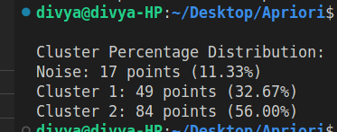

Knime Output:
Weka Output:

Conclusion
Clustering algorithms were successfully applied to group similar data points in the dataset. The results from K-Means, Hierarchical, and DBSCAN effectively identified meaningful clusters and showed the distribution of data among them. While K-Means and Hierarchical provide structured grouping, DBSCAN also identifies noise and clusters of arbitrary shape. Overall, clustering helps to analyze patterns, understand data distribution, and extract useful insights from unlabeled data.

